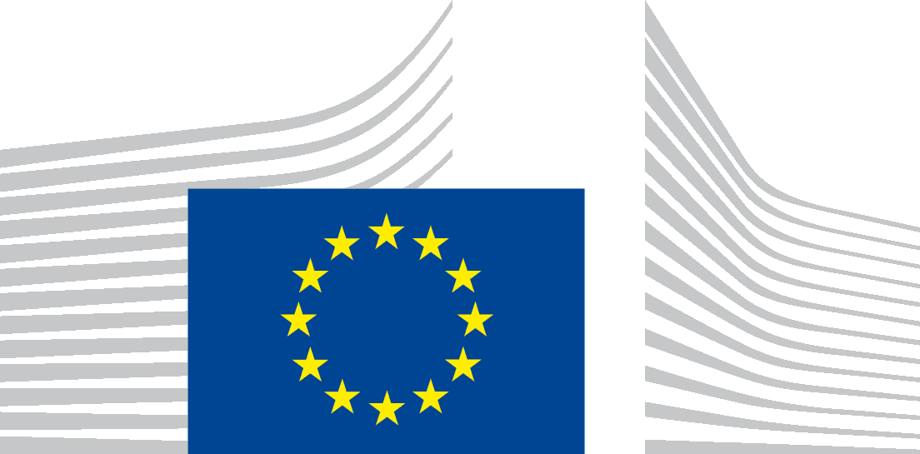 | EUROPEAN COMMISSION  DIRECTORATE-GENERAL FOR MOBILITY AND TRANSPORT

CONSENT FORM
I, (insert name)
☐ By checking this box, confirm that I have read the below Privacy Statement and agree with the processing of my personal data for the purposes stated therein.
☐ By checking this box, acknowledge that my views will be shared with the European Commission and may be published with information concerning the country, name and type of the organisation/profession that I represent, to which I hereby give my consent.

☐ By checking this box, undertake that, after the consultation, I will explicitly inform the Commission (Data Controller), Milieu Consulting SRL (nominated Data Processor for such purposes) if I do not accept the publication of some of the information shared. In this case, I will clearly identify the data concerned and will clarify whether it should not be published or whether it could be published but without the name of the organisation I represent.

PROTECTION OF YOUR PERSONAL DATA
This privacy statement provides information about
the processing and the protection of your personal data.

Processing operation: Targeted consultation activities in the form of interviews and surveys in relation to the Commission’s ‘Support study for the report on the implementation and results of Regulation (EU) 2021/782 on rail passengers’ rights and obligations’.
Data Controller: European Commission, Directorate-General for Mobility and Transport, Unit B5 Social Aspects, Passenger Rights & Equal Opportunities.
Data Processor: Ramboll Management Consulting SA/NV, Transport & Mobility Leuven NV, Milieu Consulting SRL, collectively ‘the contractor’, and their external experts as sub-processors, working on behalf and for account of the Data controller.
Record reference: DPR-EC-01011.4

Table of Contents
- Introduction
- Why and how do we process your personal data?
- On what legal ground(s) do we process your personal data?
- Which personal data do we collect and further process?
- How long do we keep your personal data?
- How do we protect and safeguard your personal data?
- Who has access to your personal data and to whom is it disclosed?
- What are your rights and how can you exercise them?
- Contact information
- Where to find more detailed information?

- Introduction
The European Commission (hereafter ‘the Commission’) is committed to protect your personal data and to respect your privacy. The Commission collects and further processes personal data pursuant to Regulation (EU) 2018/1725 of the European Parliament and of the Council of 23 October 2018 on the protection of natural persons with regard to the processing of personal data by the Union institutions, bodies, offices and agencies and on the free movement of such data (repealing Regulation (EC) No 45/2001).
This privacy statement explains the reason for the processing of your personal data, the way we collect, handle and ensure protection of all personal data provided, how that information is used and what rights you have in relation to your personal data. It also specifies the contact details of the responsible Data Controller with whom you may exercise your rights, the Data Protection Officer and the European Data Protection Supervisor.
This privacy statement concerns the processing operation ‘Targeted consultation activities’ in the form of interviews and surveys in relation to the Commission’s ‘Support study for the report on the implementation and results of Regulation (EU) 2021/782 on rail passengers’ rights and obligations’ (hereafter, the ‘Study'), undertaken by Unit B5 Social Aspects, Passenger Rights & Equal Opportunities of the European Commission, Directorate-General for Mobility and Transport as presented below. The targeted consultation activities will be carried out by the contractors and their subcontractors on behalf and for account of the European Commission. For this purpose, the contractors shall act as Data Processors and their subcontractors as sub-processors.
- Why and how do we process your personal data?
Purpose of the processing operation: The European Commission collects and uses your personal information within the framework of targeted consultation activities.
More specifically, this concerns carrying out interviews and surveys in order to:
- Obtain the views of the respondents concerned by the subject matter of the targeted consultation activities at hand (hereafter, 'targeted consultations'). In order to get a better understanding on the application, implementation and results of Regulation (EU) 2021/782 on rail passengers’ rights and obligations, it is indispensable for the Commission to receive input and views from those who are considered to be concerned by the topic.
- Obtain the views of stakeholders to explore a subject for which limited information is available. These targeted consultations will provide further information to the Commission necessary to take basic conceptual decisions.
For reasons of transparency and openness, in principle, your views could be published on a Europa website, either directly as received, in the form of a summary report, or included in a wider policy document. Your identity is only published together with your contribution if you consent to the publication of your identity. Only the name and type of the organisation on whose behalf you are contributing, as well as the country where your organisation is based in, will be included in the study report which would feed into further Commission’s work and research on this topic. If you are an individual expert, only the type of your profession (e.g. lawyer) and your country will be included.
Similarly, audio- or video recordings are only published based on your explicit consent.
The subject matter of the consultation activity requires you to provide personal data in your response. These personal data will only be published subject to your explicit consent.
It is your responsibility if you opt for confidentiality of your personal data to avoid any reference in your submission or contribution that would reveal your identity.
To avoid misuse, anonymous contributions to the consultation activity may not be accepted.
The consultation activity uses the Commission's online questionnaire tool EUSurvey that requires you to login via your ‘EU Login’ or ‘social media account’. ‘EU Login’ requires certain personal data such as the name, surname and e-mail address of the registrant. For further information, please refer to the privacy statements of ‘EU Login’ and ‘EU Survey’ as well as the processing operations ‘Identity & Access Management Service (IAMS)' (reference number in the public DPO register: DPR-EC-03187) and ‘EUSurvey’ (reference number: DPR-EC-01488). Should you choose to log in through your social media account, please refer to the pertinent social media platform’s privacy statement.
Your contribution to the targeted consultation is stored in the Commission’s document management system (for further information on the Commission’s document management system please refer to the processing operation ‘Management and (short- and medium-term) preservation of Commission documents`, reference number: DPR-EC-00536).
The personal data processed may be reused for the purpose of procedures before the EU Courts, national courts, the European Ombudsman or the European Court of Auditor.
Your personal data will not be used for an automated decision-making including profiling.

- On what legal ground(s) do we process your personal data?
We process your personal data, because:

(a) processing is necessary for the performance of a task carried out in the public interest;
(b) processing is necessary for compliance with a legal obligation to which the controller is subject;
(c) it is based on your consent, for one or more specified purposes:
- Publication of the identity of the stakeholder or respondent;
- Publication of audio or video recordings;
- If the subject matter of a targeted consultation requires respondents to provide personal data in their response, their publication;
- if applicable, the processing of special categories of personal data.

The Union law which is the basis for the processing based on Articles 5(1)(a) and (b) of Regulation (EU) 2018/1725 is the Treaty of the European Union, and more specifically its Articles 1 and 11, Article 298 of the Treaty on the Functioning of the European Union, read in conjunction with Recital 22 of Regulation (EU) 2018/1725), as well as the Protocol 2 on the application of the principles of subsidiarity and proportionality.

- Which personal data do we collect and further process?
In order to carry out this processing operation the Data Processor on behalf and for the account of the Data Controller could collect the following categories of personal data:

- name and surname,
- position in the organisation (or your profession if you are an individual expert),
- country in which the organisation/expert is based,
- e-mail address of the respondent,
- telephone number of the respondent (if applicable),
- the name and type of the organisation on whose behalf the respondent is contributing,
- audio or video recordings of the interviews (if applicable),
- personal data related to the physical, economic, cultural, or social identity of the respondent, insofar as they are not falling under Article 10 of the Regulation,
- personal data included in the response or contribution to the targeted consultation.

Furthermore, you may spontaneously provide other, non-requested personal data in the context of your reply to the targeted consultation.

- How long do we keep your personal data?
The Data Controller as well as the Data Processor (including sub-processors) only keeps your personal data for the time necessary to fulfil the purpose of collection or further processing, namely for a maximum of five years after the closure of the file to which the present targeted consultations belong. A file is closed at the latest once there has been a final outcome in relation to the initiative to which the targeted consultation contributed. This retention period is without prejudice to an earlier elimination of personal data not part of the file or cases of administrative elimination.
This administrative retention period of five years is based on the retention policy of European Commission documents and files (and the personal data contained in them), governed by the common Commission-level retention list for European Commission files SEC(2019)900. It is a regulatory document in the form of a retention schedule that establishes the retention periods for different types of European Commission files. That list has been notified to the European Data Protection Supervisor.
The administrative retention period is the period during which the European Commission departments are required to keep a file depending on its usefulness for administrative purposes and the relevant statutory and legal obligations. This period begins to run from the time when the file is closed.
In accordance with the common Commission-level retention list, after the ‘administrative retention period’, files including (the outcome of) targeted consultations (and the personal data contained in them) can be transferred to the Historical Archives of the European Commission for historical purposes (for the processing operations concerning the Historical Archives, please see record of processing 'Management and long-term preservation of the European Commission's Archives’, registered under reference number DPR-EC-00837).
- How do we protect and safeguard your personal data?
All personal data in electronic format (e-mails, documents, databases, uploaded batches of data, etc.) are stored on the servers of the European Commission or of its contractors. All processing operations are carried out pursuant to Commission Decision (EU, Euratom) 2017/46 of 10 January 2017 on the security of communication and information systems in the European Commission.
In order to protect your personal data, the Commission has put in place a number of technical and organisational measures. Technical measures include appropriate actions to address online security, risk of data loss, alteration of data or unauthorised access, taking into consideration the risk presented by the processing and the nature of the personal data being processed. Organisational measures include restricting access to the personal data solely to authorised persons with a legitimate need to know for the purposes of this processing operation.
The Commission’s processors (contractors) are bound by a specific contractual clause for any processing operations of your personal data on behalf of the Commission. The processors have to put in place appropriate technical and organisational measures to ensure the level of security, required by the Commission.
- Who has access to your personal data and to whom is it disclosed?
Access to your personal data is provided to the staff of the Commission and to the staff of contractors, who are responsible for carrying out this Study and to authorised staff according to the “need to know” principle, in particular to follow-up on the targeted consultations. In addition, the contractors work with a limited number of national external experts who act as sub-processors. These external experts will only be involved in conducting interviews with stakeholders. Such staff abide by statutory, and when required, additional confidentiality and data processing agreements.
Certain personal data may be made public on the Europa website, namely:
- any personal data on which you consented to their publication;
- personal data spontaneously provided by you in your contribution (without it being required by the consultation activity).
Please note that pursuant to Article 3(13) of Regulation (EU) 2018/1725 public authorities (e.g. Court of Auditors, EU Court of Justice) which may receive personal data in the framework of a particular inquiry in accordance with Union or Member State law shall not be regarded as recipients; the processing of those data by those public authorities shall be in compliance with the applicable data protection rules according to the purposes of the processing.
The information we collect will not be given to any third party, except to the extent and for the purpose we may be required to do so by law.
- What are your rights and how can you exercise them?
You have specific rights as a ‘data subject’ under Chapter III (Articles 14-25) of Regulation (EU) 2018/1725, in particular the right to access your personal data and to rectify them in case your personal data are inaccurate or incomplete. Under certain conditions, you have the right to erase your personal data, to restrict the processing of your personal data, to object to the processing and the right to data portability.

You have the right to object to the processing of your personal data, which is lawfully carried out pursuant to Article 5(1)(d), on grounds relating to your particular situation.

Insofar you have consented to the certain processing of your personal data by the Data Controller and by the Data Processor (including its sub-processors) for the present processing operation, you can withdraw your consent at any time by notifying the Data Controller or the Data Processor. The withdrawal will not affect the lawfulness of the processing carried out before you have withdrawn the consent.

You can exercise your rights by contacting the Data Controller, or in case of conflict the Data Protection Officer. If necessary, you can also address the European Data Protection Supervisor. Their contact information is given under Heading 9 below.
Where you wish to exercise your rights in the context of one or several specific processing operations, please provide their description (i.e. their Record reference(s) as specified under Heading 10 below) in your request.
Any request for access to personal data will be handled within one month. Any other request mentioned above will be addressed within 15 working days.
- Contact information
- The Data Controller
If you would like to exercise your rights under Regulation (EU) 2018/1725, or if you have comments, questions or concerns, or if you would like to submit a complaint regarding the collection and use of your personal data, or if you would like to inform the Commission in case you do not accept the publication of some of the information shared, please feel free to contact the Data Controller of the European Commission, Unit B5 Social Aspects, Passenger Rights & Equal Opportunities, Directorate-General for Mobility and Transport, MOVE-RAIL-PASSENGERS-RIGHTS@ec.europa.eu
- The Data Processor
In case you do not accept the publication of some of the information you shared during the targeted consultation, you can inform Milieu Consulting SRL at privacy@milieu.be
- The Data Protection Officer (DPO) of the Commission
You may contact the Data Protection Officer (DATA-PROTECTION-OFFICER@ec.europa.eu) with regard to issues related to the processing of your personal data under Regulation (EU) 2018/1725.

- The European Data Protection Supervisor (EDPS)

You have the right to have recourse (i.e. you can lodge a complaint) to the European Data Protection Supervisor (edps@edps.europa.eu) if you consider that your rights under Regulation (EU) 2018/1725 have been infringed as a result of the processing of your personal data by the Data Controller.
- Where to find more detailed information?
The Commission Data Protection Officer (DPO) publishes the register of all processing operations on personal data by the Commission, which have been documented and notified to him. You may access the register via the following link: http://ec.europa.eu/dpo-register.
This specific processing operation has been included in the DPO’s public register with the following Record reference: DPR-EC-01011.4.

